Waffle Link: <https://waffle.io/DhirajGurnani/umlparsercmpe202>

Github Link: <https://github.com/DhirajGurnani/umlparsercmpe202>

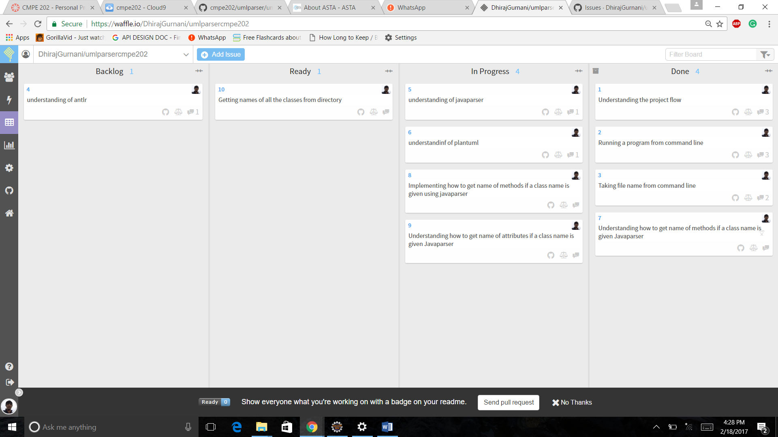

|  |  |  |  |  |
| --- | --- | --- | --- | --- |
| **Issues:** | **Backlog:** | **Ready:** | **In- progress:** | **Done:** |
| Understanding the project flow |  | Feb 13  3:21 pm | Feb 13  3:22 pm | Feb 13  8:15 pm |
| Running a program from command line |  | Feb 13  8:16 pm | Feb 13  8:17 pm | Feb 13  9:10 pm |
| Taking file name from command line |  | Feb 13  9:16 pm | Feb 13  9:16 pm | Feb 13  11:20 pm |
| understanding of antlr | Feb 14  11:30 pm |  |  |  |
| understanding of javaparser |  | Feb 15  3:31 pm | Feb 15  3:31 pm |  |
| understanding of plantuml |  | Feb 15  6:30 pm | Feb 15  6:30 pm |  |
| Understanding how to get name of methods if a class name is given Javaparser |  | Feb 15  4:30 pm | Feb 15  4:30 pm | Feb 18  4:30 pm |
| Implementing how to get name of methods if a class name is given using javaparser |  | Feb 18  4:30 pm | Feb 18  4:30 pm |  |
| Understanding how to get name of attributes if a class name is given Javaparser |  | Feb 18  4:30 pm | Feb 18  4:30 pm |  |
| Getting names of all the classes from directory |  | Feb 18  4:30 pm |  |  |

|  |  |  |  |
| --- | --- | --- | --- |
| **Issues:** | **Status:** | **Total Cycle Time:** | **In- progress Time** |
| Understanding the project flow | Done | 5 hours |  |
| Running a program from command line | Done | 1 hour |  |
| Taking file name from command line | Done | 2 hours |  |
| understanding of antlr | Backlog |  |  |
| understanding of javaparser | In Progress |  | 5 Days |
| understanding of plantuml | In Progress |  | 5 Days |
| Understanding how to get name of methods if a class name is given Javaparser | Done | 3 Days |  |
| Implementing how to get name of methods if a class name is given using javaparser | In Progress |  | 3 hours |
| Understanding how to get name of attributes if a class name is given Javaparser | In Progress |  | 3 hours |
| Getting names of all the classes from directory | Ready |  |  |